**Project on**

**Prozzila - A Project and Task Management System**

**Submitted by**

SYED FOYEZ UDDIN

181400106

MIRZA ALAMIN HOSSEN

193400037

in partial fulfilment of the requirement for the degree of Bachelor of Science in Computer

Science and Engineering



Department of Computer Science and Engineering

Faculty of Engineering and Technology

Eastern University

January 2024

**Declaration**

We hereby declare that the work is being presented in this project entitled **“Prozzila - A Project and Task Management System”** in partial fulfilment of the requirement for the degree of Bachelor of Science in Computer Science and Engineering under the faculty of ­­Engineering and Technology, Eastern University, Bangladesh is an authentic record of our own work carried out under the supervision of **Tanzim Tamanna Shitu.** It is also declared neither this report nor any part of it has been submitted elsewhere for the award of any kind of degree.

**Syed Foyez Uddin**

**Mirza Alamin Hossen**

**Approval**

The project titled “**Prozzila - A Project and Task Management System**” submitted by **Syed Foyez Uddin (181400106), Mirza Alamin Hossen (193400037)** has been accepted satisfactorily in partial fulfilment of the requirement for the degree of Bachelor of Science in Computer Science and Engineering.

**Board of Examiners**

|  |  |  |
| --- | --- | --- |
| **Tanzim Tamanna Shitu** |  |  |
| Lecturer  Department of Computer Science and Engineering  Eastern University |  | Chairman  (Supervisor) |

|  |  |  |
| --- | --- | --- |
| **Muhammad Mahfuz Hasan** |  |  |
| Associate Professor and Chairperson  Department of Computer Science and Engineering  Eastern University |  | Member  (Ex-Officio) |

|  |  |  |
| --- | --- | --- |
| **Tasniah Mohiuddin** |  |  |
| Lecturer  Department of Computer Science and Engineering  Eastern University |  | Member |

|  |  |  |
| --- | --- | --- |
| **Amrita Biswas** |  |  |
| Lecturer  Department of Computer Science and Engineering  Eastern University |  | Member |

**Acknowledgement**

First of all, we would like to thank the almighty ALLAH. Today we are successful in completing our work with such ease because He gave us the ability, chance, and cooperating supervisor.

We would like to take the opportunity to express our gratitude to Tanzim Tamanna Shitu, our respected supervisor although, she was always loaded with several other activities, she gave us more than enough time in this work. She not only gave use time but also proper guidance and valuable advice whenever we faced with some difficulties. Her comments and guidance helped us in preparing our project and project report.

We are thankful to the Department of Computer Science & Engineering, Eastern University, for providing us with an excellent educational environment and computing facility. We also offer our best regards Eastern University administration, and all other esteemed teachers of the department for their affectionate feelings and encouragement throughout the period of our project work.

Last of all, we are grateful to our family and our teachers, who are always with us.

**Abstract**

In today's dynamic and fast-paced work environment, effective project and task management are pivotal for organizational success. Prozzila introduces innovative features including user specific task assignment, comprehensive project timelines, real-time collaboration tools, and customizable task management features. The system's adaptability across diverse industries is ensured through its user-friendly interface and customization options.

Furthermore, Prozzila incorporates robust encryption measures, acknowledging the importance of data security and privacy. Its scalability caters to the distinct needs of various project sizes and complexities, ensuring versatility in implementation.

This project's goal is to align with industry standards, promoting a collaborative and organized approach to project management within academic and professional space. By empowering users to deliver successful projects, Prozzila aims to contribute to the advancement of organizational productivity, presenting a practical and functional solution to real-world challenges in project and task management.

**Table of Content**

|  |  |  |  |  |  |  |
| --- | --- | --- | --- | --- | --- | --- |
| **Content** | | | | | | **Page** |
| Abstract ------------------------------------------------------------------------------------------- | | | | | | v |
| List of Figures ----------------------------------------------------------------------------------- | | | | | | viii |
| List of Tables ----------------------------------------------------------------------------------- | | | | | | ix |
|  | | | | | | |
| **Chapter 1: Introduction** | | | | | | **1-4** |
| 1.1 | Introduction --------------------------------------------------------------------------- | | | | | 1 |
| 1.2 | Motivation ---------------------------------------------------------------------------- | | | | | 2 |
| 1.3 | Objective ------------------------------------------------------------------------------ | | | | | 2 |
| 1.4 | Tools ---------------------------------------------------------------------------------- | | | | | 3 |
| 1.5 | Methodology ------------------------------------------------------------------------- | | | | | 3 |
|  | 1.5.1 | Project Schedule ------------------------------------------------------------ | | | | 4 |
| 1.6 | Expected Outcome ------------------------------------------------------------------ | | | | | 4 |
|  |  | | | | |  |
| **Chapter 2: Project Specification** | | | | | | **5-10** |
| 2.1 | Introduction -------------------------------------------------------------------------- | | | | | 5 |
| 2.2 | Feasibility Study -------------------------------------------------------------------- | | | | | 5 |
|  | 2.2.1 | Technical Feasibility-------------------------------------------------------- | | | | 5 |
|  | 2.2.2 | Operational Feasibility------------------------------------------------------ | | | | 5 |
|  | 2.2.3 | Economic Feasibility------------------------------------------------------ | | | | 6 |
| 2.3 | System Design ----------------------------------------------------------------------- | | | | | 6 |
| 2.4 | General Function Description ----------------------------------------------------- | | | | | 7 |
| 2.5 | Requirements ------------------------------------------------------------------------- | | | | | 7 |
| 2.6 | Modeling ------------------------------------------------------------------------------ | | | | | 8 |
| 2.7 | Main Functionalities ----------------------------------------------------------------- | | | | | 9 |
| 2.8 | Challenges ---------------------------------------------------------------------------- | | | | | 10 |
|  |  | | | | |  |
| **Chapter 3: System Design and Analysis** | | | | | | **11-27** |
| 3.1 | Use Case Modelling and Description -------------------------------------------- | | | | | 11 |
|  | 3.1.1 | | Use Case for Admin ------------------------------------------------------ | | | 12 |
|  | 3.1.2 | | Use Case for User---------------------------------------------------------- | | | 12 |
|  | 3.1.3 | | Use Case Description of Admin------------------------------------------ | | | 13 |
|  | 3.1.4 | | Use Case Description of User------------------------------------------ | | | 13 |
| 3.2 | ER Diagram -------------------------------------------------------------------------- | | | | | 14 |
| 3.3 | Data Flow Diagram ----------------------------------------------------------------- | | | | | 15 |
|  | 3.3.1 | | | Data Flow Diagram Level 0 -------------------------------------------- | | 15 |
|  | 3.3.2 | | | Data Flow Diagram Level 1 -------------------------------------------- | | 15 |
| 3.4 | System Flow Chart------------------------------------------------------------------- | | | | | 16 |
|  | 3.4.1 | | | Activity Diagram for Assign Task ------------------------------------- | | 16 |
|  | 3.4.2 | | | State-chart Diagram for project ----------------------------------------- | | 17 |
| 3.5 | Snapshot of Database ---------------------------------------------------------------- | | | | | 18 |
| 3.6 | Snapshot of Front-end --------------------------------------------------------------- | | | | | 19 |
|  | 3.6.1 | | | Home Page ----------------------------------------------------------------- | | 19 |
|  | 3.6.2 | | | User Login Page ---------------------------------------------------------- | | 20 |
|  | 3.6.3 | | | Admin Login Page-------------------------------------------------------- | | 20 |
|  | 3.6.4 | | | Dashboard Page ----------------------------------------------------------- | | 21 |
|  | 3.6.5 | | | User Profile Page --------------------------------------------------------- | | 22 |
|  | 3.6.6 | | | Task Page ------------------------------------------------------------------ | | 23 |
|  | 3.6.7 | | | Create Task Page ---------------------------------------------------------- | | 23 |
|  | 3.6.8 | | | Assign Task Page --------------------------------------------------------- | | 24 |
|  | 3.6.9 | | | Kanban Board Page ------------------------------------------------------- | | 25 |
|  | 3.6.10 | | | Assign to Card Page ------------------------------------------------------ | | 26 |
|  | 3.6.11 | | | View Card Page ----------------------------------------------------------- | | 26 |
|  | 3.6.12 | | | New Project Page --------------------------------------------------------- | | 27 |
|  | | | | | | |
| **Chapter 4: Implementation and Testing** | | | | | | **28-33** |
| 4.1 | Introduction --------------------------------------------------------------------------- | | | | | 28 |
|  | 4.1.1 | | | Requirement Collection and Analysis --------------------------------- | | 28 |
|  | 4.1.2 | | | Design Requirements ----------------------------------------------------- | | 29 |
|  | 4.1.3 | | | Completion ---------------------------------------------------------------- | | 29 |
|  | 4.1.4 | | | Project Deliverables ------------------------------------------------------ | | 30 |
|  | 4.1.5 | | | Resource Allocation ------------------------------------------------------ | | 30 |
| 4.2 | Pass/Fail Criteria --------------------------------------------------------------------- | | | | | 31 |
|  | 4.2.1 | | | | Testing Schedule ---------------------------------------------------------- | 31 |
| 4.3 | Testing Environment---------------------------------------------------------------- | | | | | 32 |
| 4.4 | Testing Implementation ------------------------------------------------------------- | | | | | 32 |
| 4.5 | Test Results and Reports ------------------------------------------------------------ | | | | | 33 |

|  |  |  |  |
| --- | --- | --- | --- |
| **Chapter 5: Conclusion and Future Works** | | | **34-36** |
|  | 5.1 | Conclusion ---------------------------------------------------------------- | 34 |
|  | 5.2 | Future Work -------------------------------------------------------------- | 35 |
| **References** ------------------------------------------------------------------------------------- | | | 36 |

**List of Figures**

|  |  |  |
| --- | --- | --- |
| **Figure No.** | **Figure Name** | **Page** |
| Fig 2.5 | Prototyping Process ------------------------------------------------------------- | 8 |
| Fig 3.1.1 | Use Case Diagram for Admin ------------------------------------------------- | 12 |
| Fig 3.1.2 | Use Case Diagram for User ---------------------------------------------------- | 12 |
| Fig 3.2.1 | ER Diagram ---------------------------------------------------------------------- | 14 |
| Fig 3.3.1 | Data Flow Diagram Level 0 --------------------------------------------------- | 15 |
| Fig 3.3.2 | Data Flow Diagram Level 1 --------------------------------------------------- | 15 |
| Fig 3.4.1 | Activity Diagram for Assign Task -------------------------------------------- | 16 |
| Fig 3.4.2 | State-Chart Diagram for Project ----------------------------------------------- | 17 |
| Fig 3.5 | Database Tables **-------------------------------------------**---------**-------------** | 18 |
| Fig 3.6.1 | Home Page ----------------------------------------------------------------------- | 19 |
| Fig 3.6.2 | User Login Page ---------------------------------------------------------------- | 20 |
| Fig 3.6.3 | Admin Login Page -------------------------------------------------------------- | 20 |
| Fig 3.6.4 | Dashboard Page ------------------------------------------------------------------ | 21 |
| Fig 3.6.5 | User Profile Page ---------------------------------------------------------------- | 22 |
| Fig 3.6.6 | Task Page ------------------------------------------------------------------------- | 23 |
| Fig 3.6.7 | Create Task Page ---------------------------------------------------------------- | 23 |
| Fig 3.6.8 | Assign Task Page ---------------------------------------------------------------- | 24 |
| Fig 3.6.9 | Kanban Board Page ------------------------------------------------------------- | 25 |
| Fig 3.6.10 | Assign to Card Page ------------------------------------------------------------- | 26 |
| Fig 3.6.11 | View Card Page ------------------------------------------------------------------ | 26 |
| Fig 3.6.12 | New Project Page ---------------------------------------------------------------- | 27 |
| Fig 4.1.2 | Website Working Procedure --------------------------------------------------- | 29 |

**List of Tables**

|  |  |  |
| --- | --- | --- |
| **Table No.** | **Table Name** | **Page** |
| Tab 1.5.1 | Project Schedule ----------------------------------------------------------------- | 4 |
| Tab 3.1.3 | Use Case Description of Admin ----------------------------------------------- | 13 |
| Tab 3.1.4 | Use Case Description of User -------------------------------------------------- | 13 |
| Tab 4.2.1 | Testing Schedule ---------------------------------------------------------------- | 31 |

**CHAPTER 1**

**INTRODUCTION**

* 1. **Introduction**

In a world of evolving technology and workplaces, successful organizations rely on efficient project and task management. Prozzila steps onto the scene as a state-of-the-art Project and Task Management System, designed with precision to address the intricate challenges faced by project collaborators. This introduction outlines our project's core objective: to revolutionize how projects are planned, executed, and monitored. We achieved this by exploring contemporary project management methods and identifying the key needs of our users.

The complexity of the project management landscape underscores the growing need for intuitive tools that enhance collaboration, communication, and overall efficiency. Prozzila responds adeptly to this demand by presenting a feature-rich platform that fosters seamless project coordination. Informed by established project management principles and empowered by cutting-edge technologies, Prozzila introduces functionalities tailored to diverse project requirements.

Central to Prozzila are key features such as visualizing project timelines, real-time collaboration tools to empower users, and a user-friendly interface for effortless task management. This system empowers administrative bodies to efficiently allocate resources, monitor project progress of their users.

This project will delve into the functionalities and capabilities of Prozzila, aiming to illuminate the significance of advanced project and task management systems in contemporary academia and industry. By doing so, it seeks to underscore their potential to shape more efficient, collaborative, and ultimately successful project outcomes.

* 1. **Motivation**

As the demands of project management continually evolve in contemporary settings, the genesis of Prozzila a Project and Task Management System, is a direct response to the escalating need for advanced tools that elevate collaboration and streamline project workflows. The motivation driving Prozzila lies in its dedication to addressing the intricacies confronted by project users, offering a solution finely tuned to meet the dynamic challenges inherent in modern work environments.

By strategically leveraging cutting-edge technologies and adhering to established project management principles, Prozzila aspires to revolutionize the landscape of project planning, execution, and monitoring. At its core, this project is propelled by a commitment to enhance overall project efficiency, ultimately fostering successful outcomes across diverse organizational contexts. Prozzila stands as a testament to the pursuit of innovation in project management, seeking to provide a transformative solution that aligns seamlessly with the ever-changing demands of the contemporary professional landscape.

* 1. **Objectives**

The project sets out to revolutionize project management through the creation of a user-centric platform, fostering seamless collaboration, and amplifying task efficiency. At its core, this endeavor aims to empower project users with innovative tools, prominently featuring real-time collaboration features. Prozzila is designed to streamline resource allocation, project planning, and progress monitoring, thereby ensuring the successful execution of projects.

Through the strategic integration of technologies and adherence to established principles, the overarching objective is to establish new benchmarks in project and task management. Prozzila aspires to redefine industry standards, providing a transformative solution that not only meets but exceeds the evolving demands of efficient project management.

The main features of our website are:

**Admin**

a. Login

b. Logout

c. Add Projects

d. Add Tasks

e. Assign Tasks

f. Manage Kanban Board

f. Add and manage Cards

g. Assign Task in card

h. Add User Account

**User**

a. Login

b. Logout

c. View Project info

d. Complete Task

e. View Card

f. View Kanban Board

* 1. **Tools**

1. Local server

2. PhpStorm

* **Front-end**
  1. HTML
  2. CSS
  3. JS
  4. Bootstrap
* **Back-end**

1. PHP
2. MySQL
   1. **Methodology**

Methodology, regarded as a collection of procedures, techniques, tools, and documentation facilitating the system development process, serves as the guiding framework for the creation of Prozzila, our advanced Project and Task Management System. To ensure the timely completion of this project, our methodology is meticulously crafted to meet predefined goals. Commencing with a comprehensive requirement analysis, insights and user needs are identified, setting the foundation for subsequent phases. The design stage prioritizes user-centric features, leading to the development phase that emphasizes coding standards and modularity. This iterative process allows for continuous refinement, incorporating feedback and adjustments. The methodology incorporates cutting-edge techniques, leveraging the latest advancements in project management and software development. Specialized tools are judiciously employed to enhance efficiency in coding, and testing, aligning with industry best practices. In essence, our methodology ensures a systematic, efficient, and adaptive development process, ultimately resulting in the successful creation and deployment of Prozzila as a Project and Task Management System.

* + 1. **Project Schedule**

|  |  |  |
| --- | --- | --- |
| **Activities** | **Duration (in Week)** | **Total week** |
| Brainstorming | Week 1, Week 2, | 2 |
| Problem dentification | Week 3, Week 4, Week 5 | 3 |
| System Analysis | Week 6, Week 7 | 2 |
| System Design | Week 8, Week 9, Week 10 | 3 |
| Database Design | Week 11, Week 12, Week 13 | 3 |
| Front-end Design | Week 14, Week 15 | 2 |
| Backend Development and Database Connection | Week 16, Week 17, Week 18 | 3 |
| Bug hunting and fixing | Week 19, Week 20, Week 21 | 3 |

**Table 1.5.1 Project Schedule**

* 1. **Expected Outcome**

The successful deployment of 'Prozzila: A Project and Task Management System' culminates in a meticulously crafted, user-centric interface. This interface ensures a seamless and intuitive experience for both project managers and employees(users). Notably, the integration of innovative features, such as exclusive task assignment, real-time collaboration tools, enhances project coordination, leading to significantly more efficient workflows.

Prozzila undergoes rigorous testing to guarantee its reliability and robustness, establishing a stable platform for effective project management. The system's architecture is purposefully designed for scalability and adaptability, adept at accommodating the evolving complexities of projects without compromising performance. A strategic emphasis on code modularity ensures an efficient and adaptable codebase, supporting ease of maintenance and facilitating future enhancements.

Prozzila's success is geared toward making meaningful contributions to project success, ensuring client satisfaction, and advancing project management capabilities. This commitment is underscored by an ongoing dedication to improvement in the dynamic landscape of project management systems.

This refined outcome articulates the sophisticated and powerful aspects of Prozzila's deployment, emphasizing not only its usability but also its reliability, scalability, and adaptability in meeting the evolving demands of project management.

**CHAPTER 2**

**PROJECT SPECIFICATION**

1. **Introduction**

A project and task management system are a software solution designed to streamline project workflows, facilitate collaboration, and enhance efficiency by organizing and tracking tasks, timelines.

**2.2 Feasibility Study**

In the preliminary investigation of the Prozzila Project and Task Management System, a comprehensive feasibility study is conducted to assess the viability of the system within the organizational context. The primary objective is to evaluate the technical, operational, and economical feasibility, focusing on the addition of new modules and the debugging of the existing system. The feasibility study encompasses the following key aspects:

* Technical Feasibility
* Operational Feasibility
* Economic Feasibility

**2.2.1 Technical Feasibility**

Technical feasibility centers on the examination of existing computer system hardware, software, and their capability to support the proposed enhancements. This involves financial considerations for accommodating technical improvements. The success of the project is contingent upon the availability and reasonability of the required technical resources. Prozzila, designed with HTML as the front-end and SQL Server as the back-end, is easily installable across various systems. Its efficiency, user-friendliness, and capacity to handle substantial data make it technically feasible. The project ensures the resolution of existing problem areas through an efficient technical feasibility assessment.

**2.2.2 Operational Feasibility**

Operational feasibility assesses the readiness of the user staff to embrace the new system. People are inherently resistant to change, and this study estimates the reaction of the user staff towards the development of the computerized system. As computerized systems become more commonplace, the operational feasibility of Prozzila is deemed high. The familiarity of the staff with computerized systems ensures a smoother transition. Thus, Prozzila is operationally feasible.

**2.2.3 Economic Feasibility**

Economic feasibility compares the development cost with the income/benefit derived from the system. The interface design aims to meet end-user requirements economically, with minimal costs. Prozzila, developed using commonly available technologies like HTML, PHP, and SQL Server, incurs reasonable installation costs. The project's economic feasibility is further bolstered by the widespread availability of personnel skilled in PHP and SQL Server, reducing training costs. The system's efficient development, coupled with its low implementation and operating costs, establishes its economic viability.

**2.3 System Design**

The System Design phase of Prozzila, our advanced Project and Task Management System, is a crucial step in translating client requirements into a logically functioning system. This phase is undertaken in two primary steps, beginning with the Primary Design Phase and followed by the Secondary Design Phase.

**1. Primary Design Phase:**

During the Primary Design Phase, the system is conceptualized at a block level, with each block representing specific functions identified during the problem identification phase. Emphasis is placed on minimizing information flow between blocks to enhance system efficiency. The activities requiring greater interaction are consolidated within individual blocks. This phase sets the foundation for the subsequent detailed design process.

**2. Secondary Design Phase:**

In the Secondary Design Phase, detailed design for each block is performed. This involves several general tasks:

1. **Design of Various Blocks:** The overall system processes are designed in detail, with each block representing a distinct function identified in the Primary Design Phase.
2. **Design of Smaller, Compact Modules:** Within each block, smaller and more manageable modules are designed. These modules ensure workability and efficiency in handling specific functionalities.
3. **Design of Database Structures:** The design process includes defining various database structures necessary for storing and retrieving project-related data efficiently.
4. **Specification of Program Details:** Specific details of programs are outlined to achieve desired functionalities. This includes specifying the logic and algorithms necessary for the smooth execution of tasks.
5. **Design of Input and Output Forms:** The form of inputs and outputs for the system is meticulously designed, ensuring a user-friendly and intuitive interface. This design phase focuses on optimizing the user experience.
6. **System Reviews:** System reviews are conducted to evaluate the design against the established requirements and address any potential issues early in the process. This iterative review process ensures the design aligns seamlessly with project objectives.

**2.4 General Function Description**

We leverage diagrams as a pivotal tool for comprehending the comprehensive view of the system and understanding the interrelations among its elements. In our approach, diagrams serve to simplify intricate details, allowing us to concentrate on fundamental connections. The adoption of Unified Modeling Language (UML) is paramount in facilitating a clearer understanding of the system's functionalities, aligning with its key value in simplifying and visualizing complex structures.

This perspective values UML for its capacity to provide a clear and simplified representation of the system's intricate relationships. Rather than overwhelming with details, diagrams become instrumental in focusing on the essential connections between system elements. In essence, the deployment of UML emerges as an invaluable asset in our project, aiding in the seamless comprehension and effective communication of the system's functionalities.

**2.5 Requirements**

**Hardware requirements:**

1 PC with 2 GB hard-disk and 256 MB RAM

**Software requirements:**

1. Local server (XAMP, MAMP)
2. PhpStorm
3. Google Chrome

**Requirements for a Web Development Process**

The success of our web development process hinges on several pivotal requirements aimed at delivering a robust and user-friendly final product. These requirements encompass ensuring active participation from end-users, utilizing prototyping methodologies, implementing robust change management practices, establishing immediate response mechanisms, minimizing risks, eliminating administrative overhead, and maintaining transparency and guidance throughout the development journey.

The cornerstone for success lies in a profound understanding of end-users needs. Recognizing that the customer may not be the actual end user emphasizes the significance of prototyping in our development process. Prototypes serve as initial versions of the system, subject to iterative improvements based on direct end-user involvement. This iterative approach ensures that the final product aligns seamlessly with user expectations, contributing to its success in meeting real-world needs.

Prototyping plays a central role in our Web Development Process, offering a swift and effective means to identify optimal solutions, accelerate project timelines, and ensure the end product's user-friendliness. By involving users, continuously refining prototypes based on feedback, and strategically managing risks, our approach positions the final product to thrive in the ever-changing landscape of project management.

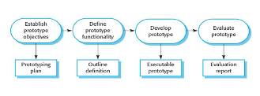

**Fig 2.5 Prototyping Process**

**2.6 Modeling:**

Modeling is an integral aspect of system development, acting as a representation of real-world entities and facilitating a deeper understanding of complex ideas. It serves multiple purposes, including problem understanding, communication aid among project stakeholders, and as a crucial component in development activities like requirements analysis.

For the Prozzila Project and Task Management System, the modeling approach employed is the Unified Modeling Language (UML), recognized as a standard language for specifying, visualizing, constructing, and documenting system artifacts. UML serves as a powerful tool for business modeling and extends beyond traditional software systems. It encompasses a collection of best practices proven successful in modeling large and complex systems.

The UML, relying on graphical notations, plays a pivotal role in expressing the design of projects within the Prozzila system. Its significance lies in fostering effective communication among project teams, exploring potential designs, and validating the architectural design of the system. The utilization of UML aligns seamlessly with the primary goals in its design:

1. **Ready-to-Use Expressive Visual Modeling Language:** UML provides users with a visually expressive modeling language that is ready-to-use, enabling the development and exchange of meaningful models. This feature enhances clarity and understanding during the project lifecycle.
2. **Extensibility and Specialization Mechanisms:** The UML offers extensibility and specialization mechanisms, allowing for the extension of core concepts. This flexibility ensures that the modeling language can adapt to the unique needs and complexities of the Prozzila Project and Task Management System.
3. **Independence of Programming Languages and Development Processes:** UML is designed to be independent of specific programming languages and development processes. This characteristic ensures versatility, allowing the modeling language to be applicable to diverse technological environments.
4. **Formal Basis for Understanding:** UML provides a formal basis for understanding the modeling language. This underpins the reliability and consistency of the language, contributing to its effectiveness as a tool for expressing and analyzing system designs.

In essence, the modeling phase for Prozzila leverages UML as a robust and versatile language, aligning with best practices to ensure effective communication, exploration of designs, and validation of system architecture throughout the development process

**2.7 Main Functionalities**

In 'Prozzila: A Project and Task Management System,' the core functionalities are meticulously outlined through the utilization of Use Cases, a storytelling technique crucial for uncovering and documenting requirements. These Use Cases are structured to accentuate the user's goals and perspective, providing a comprehensive overview of the system's capabilities.

A Use Case diagram, following the Unified Modeling Language (UML), acts as a behavioral representation, spotlighting the system's functionality concerning actors, their goals, and dependencies between these use cases. This visual representation offers a snapshot of the specific functionalities the system provides for each involved actor.

Within the context of Prozzila, the Use Case diagram describes distinctive functionalities for both users and administrators. Users can partake in activities such as modifying, uploading, downloading, or deleting files within the system, contingent upon their logged-in status. Conversely, administrators possess additional rights, enabling actions such as adding, modifying, or deleting users, as well as comprehensive project management tasks including adding new projects and modifying existing ones.

The Use Case diagram presented below spells out the specific possibilities and options available to both users and administrators within the Prozzila system. It serves as a visual guide, offering clarity on the distinct roles and functionalities each can perform within the system's framework.

**2.8 Challenges**

1. **Real-Time Updates:**
2. Challenge: Achieving real-time updates with PHP and Bootstrap.
3. Consideration: Use AJAX for periodic updates to the database pull without page reload.
4. **Task Assignment:**
5. Challenge: Create and assign tasks with PHP.
6. Consideration: Dynamically render tasks based on user assignments using PHP conditions.
7. **Card Assignment Based on Status:**
8. Challenge: Assigning cards dynamically to Kanban board sections based on their status.
9. Consideration: Utilize PHP conditions to categorize and render cards in appropriate sections, ensuring real-time updates as statuses change.
10. **User Roles and Permissions:**
11. Challenge: Managing roles and permissions with PHP.
12. Consideration: Control user actions on the Kanban board based on roles using PHP conditions.
13. **Project Addition Dynamically:**
14. Challenge: Dynamically adding projects to the system.
15. Consideration: Use PHP and Bootstrap to create a user-friendly form. Implement server-side logic to handle dynamic project creation and update the interface using Bootstrap components for seamless reflection of added projects.

**CHAPTER 3**

**SYSTEM DESIGN AND ANALYSIS**

**3.1 Use Case Modeling and Description**

A use-case model serves as a comprehensive representation of how various user types interact with the system to address specific challenges. This model delineates the users' goals, their interactions with the system, and the system's anticipated behavior in fulfilling these objectives.

A use case diagram is a graphical depiction encompassing the system, related use cases, and actors. It establishes visual connections to answer fundamental questions:

* What is being described (System)?
* Who is using the system (Actors)?
* What goals do the actors seek to achieve (Use Cases)?

By visualizing these elements, use cases play a crucial role in ensuring the development of the correct system by capturing user requirements effectively.

**Actors:**

1. Admin
2. User (Employee)

Every user, whether an Admin or an Employee, undergoes a username and password verification process during login attempts. In cases where discrepancies arise in the entered credentials, the system promptly displays a login error, enhancing security and user authentication.

**3.1.1 Use case for Admin**

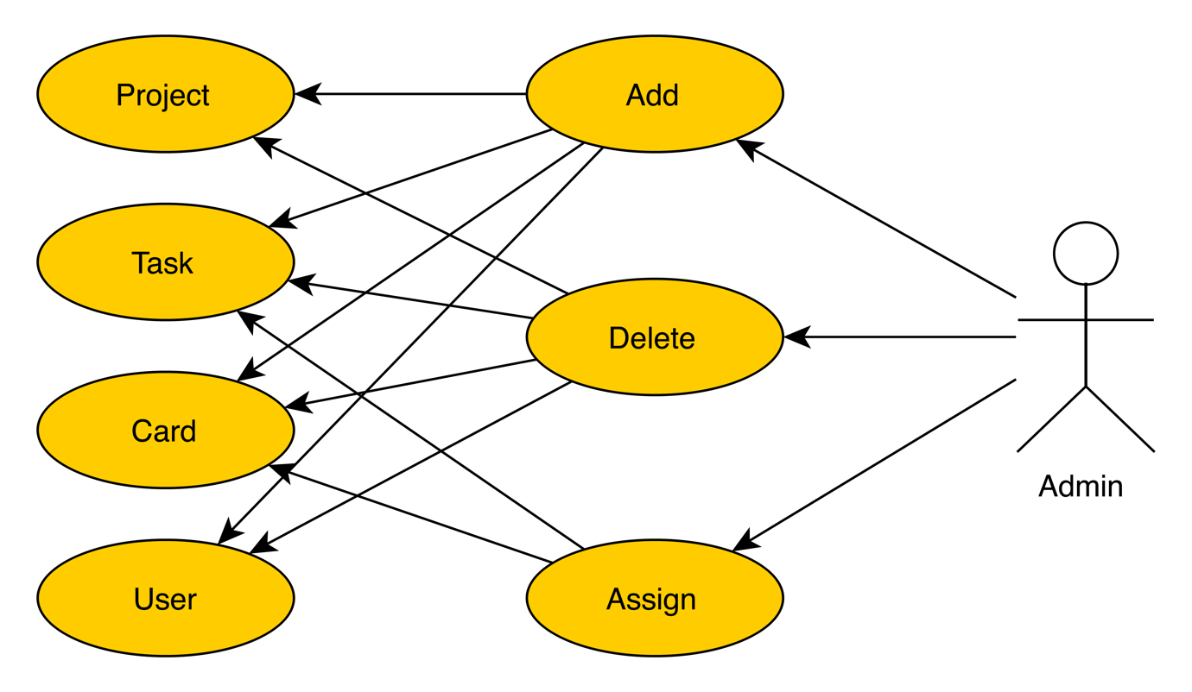

**Fig 3.1.1 Use Case Diagram for Admin**

**3.1.2 Use case for User**

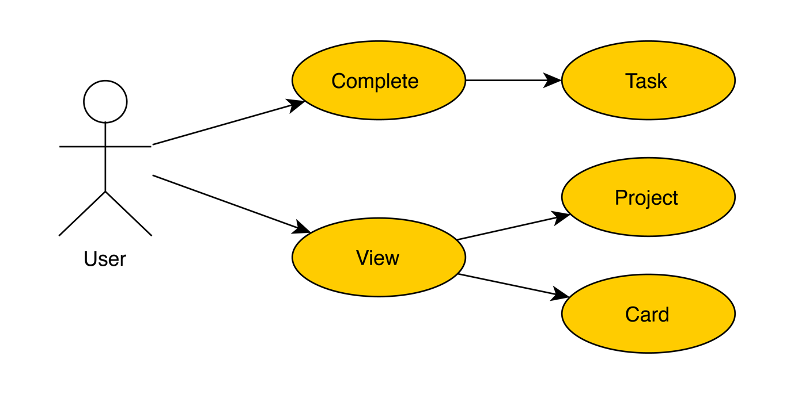

**Fig 3.1.2 Use Case Diagram for User**

**3.1.3 Use case description of Admin**

|  |  |
| --- | --- |
| Goal | Admin can login into the system and will manage Users, add project, add card, add task, assign task |
| Success and condition | Admin successfully login into the system and will manage Users |
| Failed end condition | Admin failed to login and contact with system owner |
| Primary actor | Admin |
| Main Scenario | User browse the system Click on “Sign in” |
| Pop-up window will show up |
| System redirects to the log in condition |
| Click on edit on admin users and update record (User id, email, password) |
| Manage Users, task, projects, Kanban board |

**Table 3.1.3 Use Case Description of Admin**

**3.1.4 Use case description of User**

|  |  |
| --- | --- |
| Goal | User can login into the system and will complete task, update own profile |
| Success and condition | Users successfully login into the system and will complete task |
| Failed end condition | User failed to login and contact with system owner. |
| Secondary actor | User |
| Main Scenario | User browse the system Click on “Sign in” |
| Pop-up window will show up |
| System redirects to the log in condition |
| Click on edit on users and update record (User id, email, password) |
| Complete Task form Kanban board |

**Table 3.1.4 Use Case Description of User**

**3.2 ER Diagram**

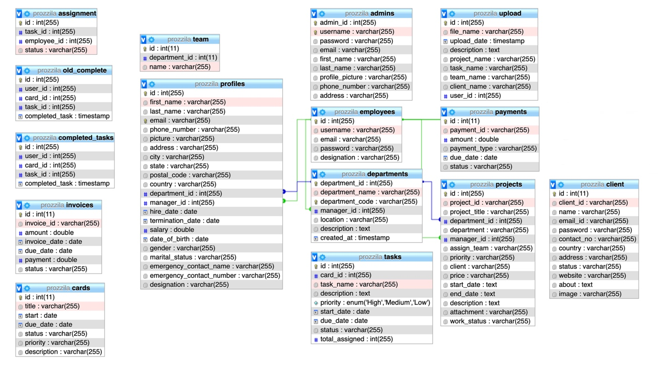

**Fig 3.2.1 ER Diagram**

**3.3 Data Flow Diagram**

**3.3.1 Data Flow Diagram Level 0**

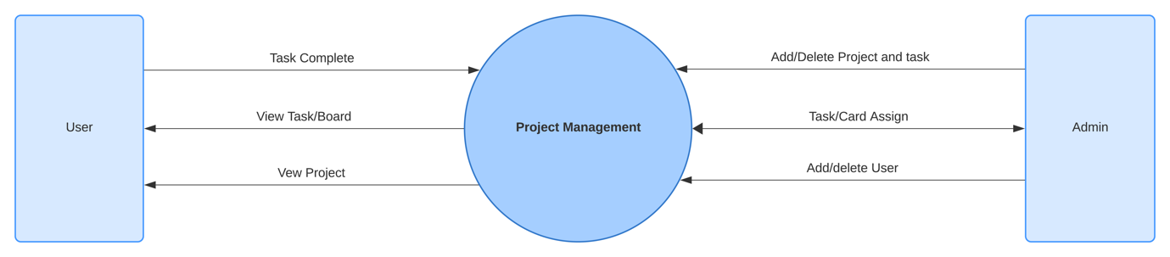

**Fig 3.3.1 Data Flow Diagram Level 0**

**3.3.2 Data Flow Diagram Level 1**

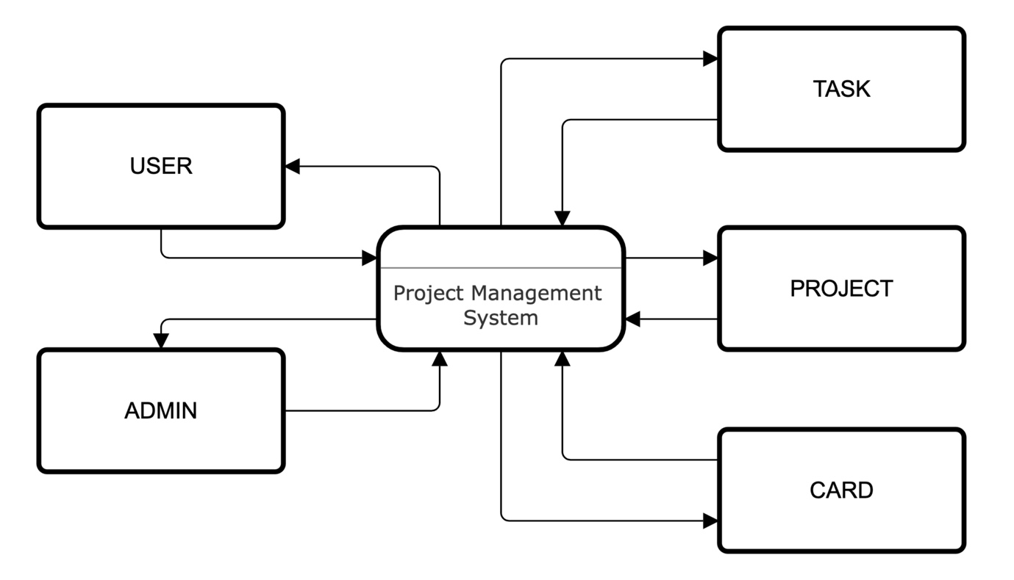

**Fig 3.3.2 Data Flow Diagram Level 1**

**3.4 System Flow Chart**

**3.4.1 Activity Diagram for Assign Task**



**Fig.3.4.1 Activity Diagram for Assign Task**

**3.4.2 State-chart Diagram for project**

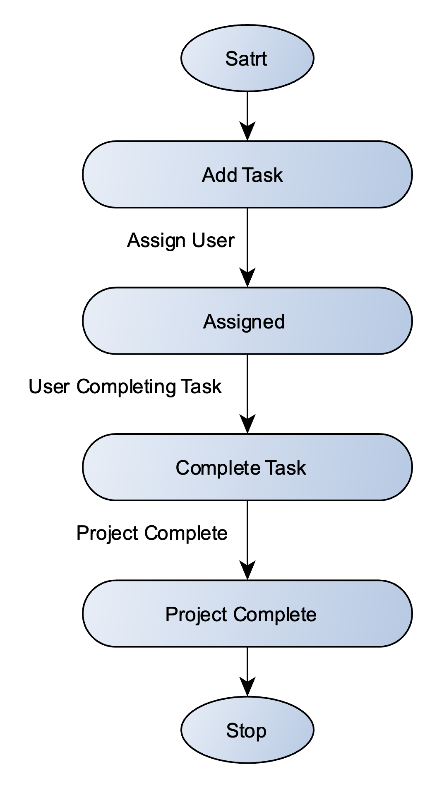

**Fig.3.4.2 State-Chart Diagram for Project**

**3.5 Snapshot of Database**

This is the screenshots of our project’s database. All the records of Admin, users, task, Kanban board, card database are maintaining and stored here. In our projects, we used phpMyAdmin local server software**.**

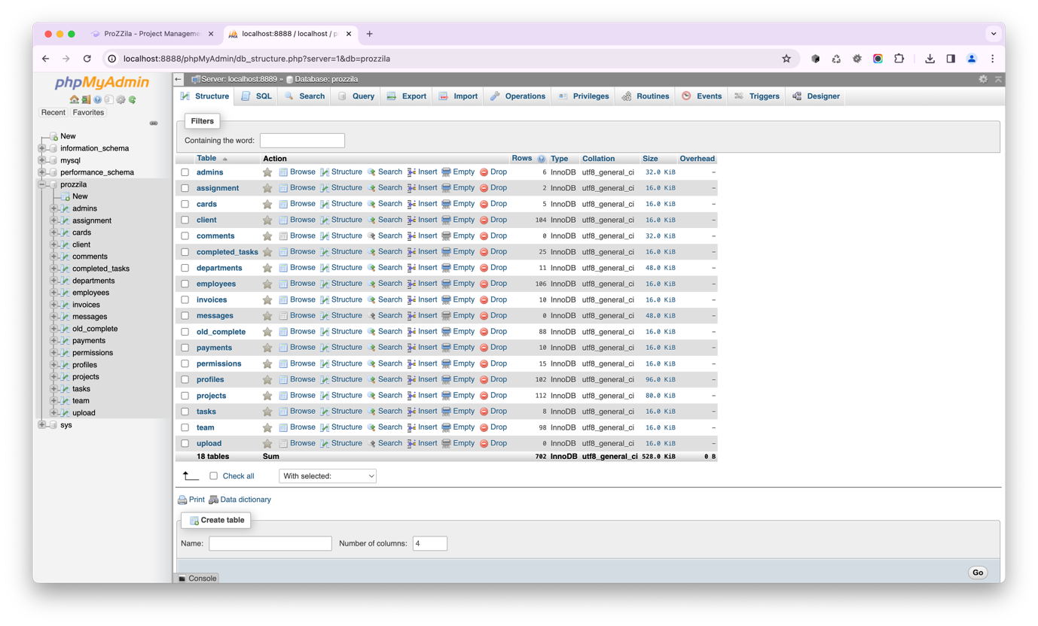

**Fig 3.5 Database Tables**

## 3.6 Snapshot of Front-end

## 3.6.1 Home Page

This is the screenshot of our project’s homepage and on this page, there are login buttons for Employee (Users) and Admin Login.

## 

## Fig 3.6.1 Home Page

## 3.6.2 User Login Page

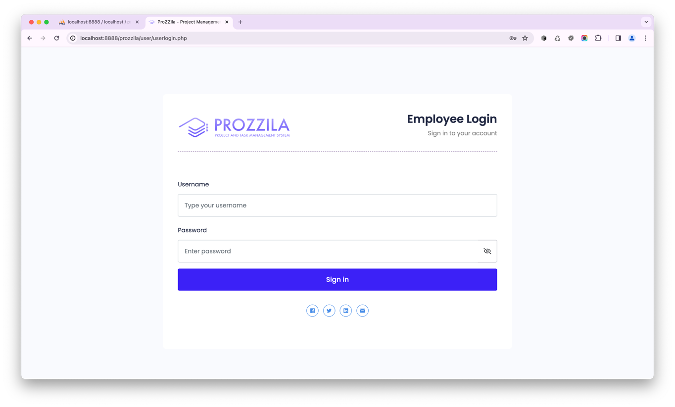This is the screenshot of our project’s User login page.

## Fig 3.6.2 User Login Page

## 3.6.3 Admin Login Page

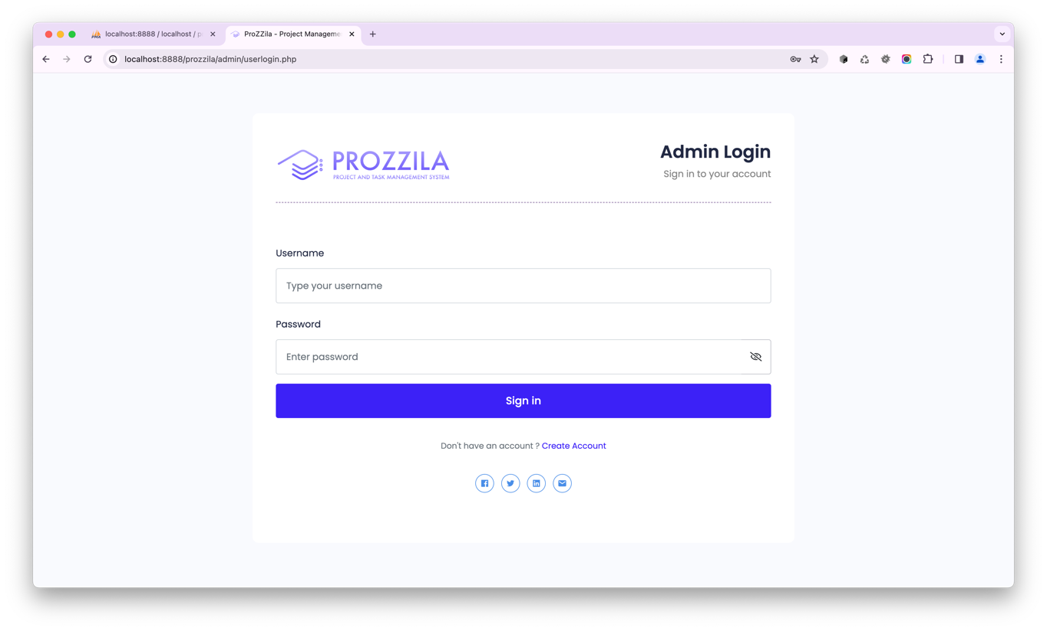This is a screenshot of our project’s Admin login page.

## Fig 3.6.3 Admin Login Page

## 3.6.4 Dashboard Page

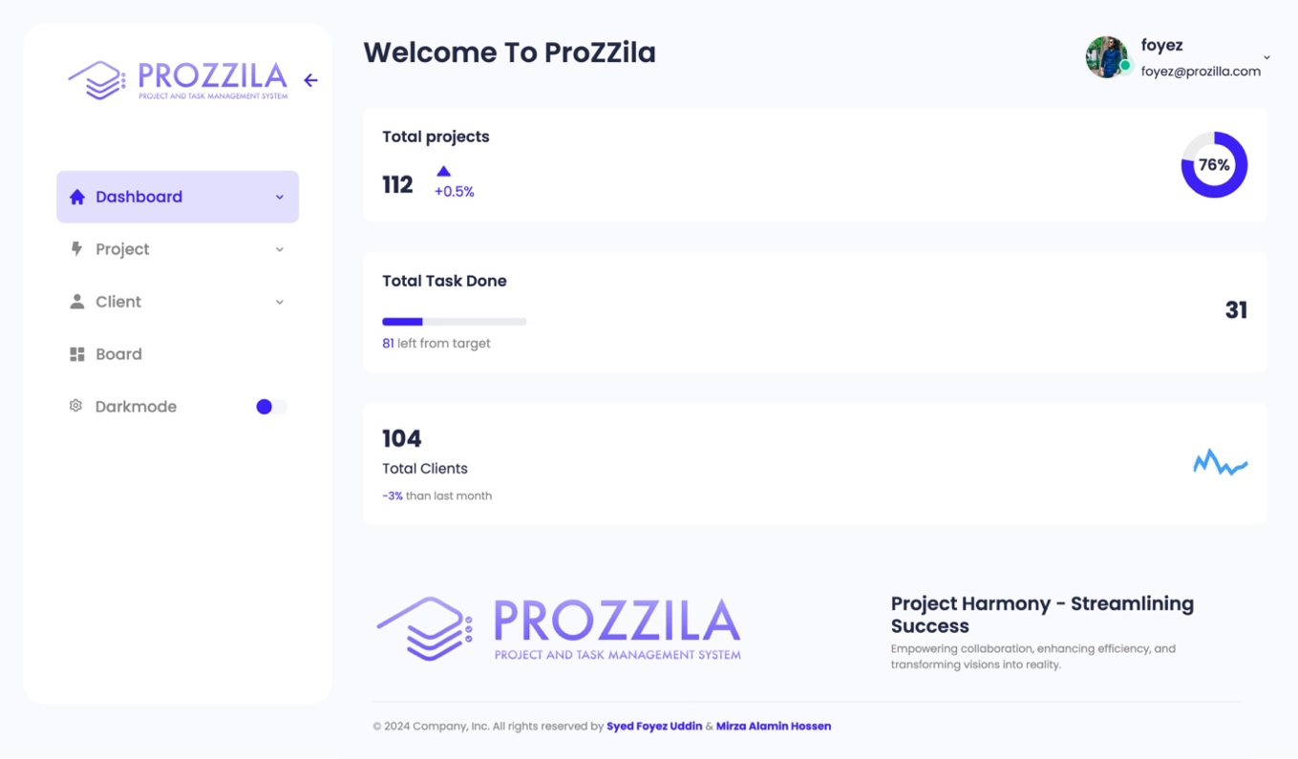This is a screenshot of project’s Dashboard Page.

## Fig 3.6.4 Dashboard Page

## 3.6.5 User Profile Page

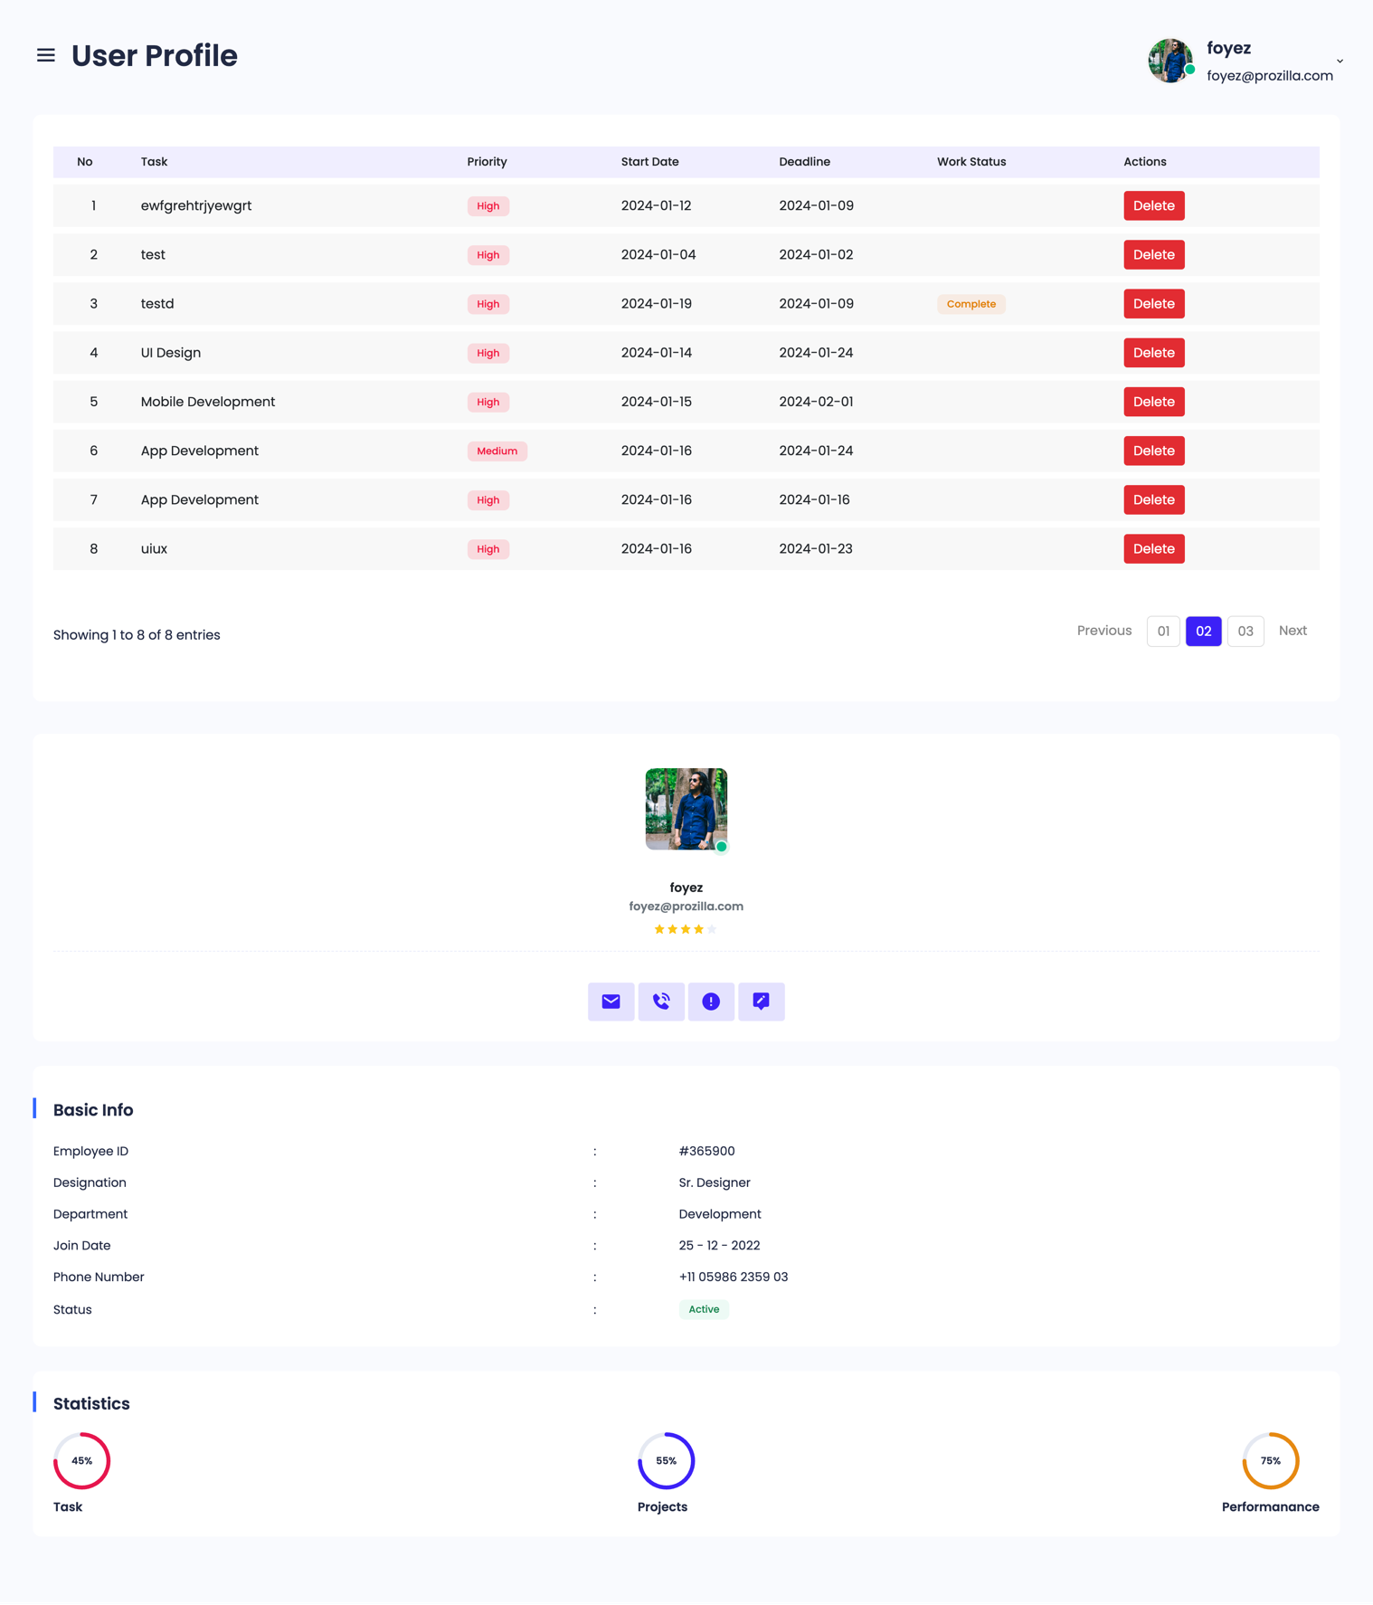This is the screenshot of project’s User Profile Page.

## Fig 3.6.5 User Profile Page

## 3.6.6 Task Page

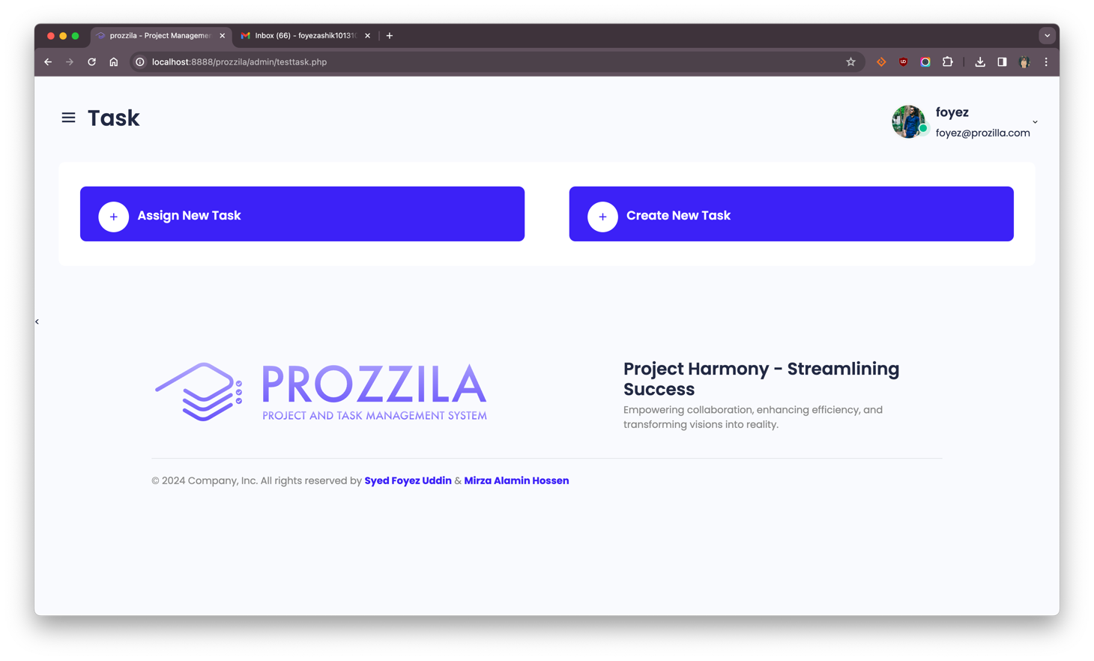The following is a screenshot of project’s Task Page and on this page, admin can create new task and assign new task to users.

## Fig 3.6.6 Task Page

## 3.6.7 Create Task Page

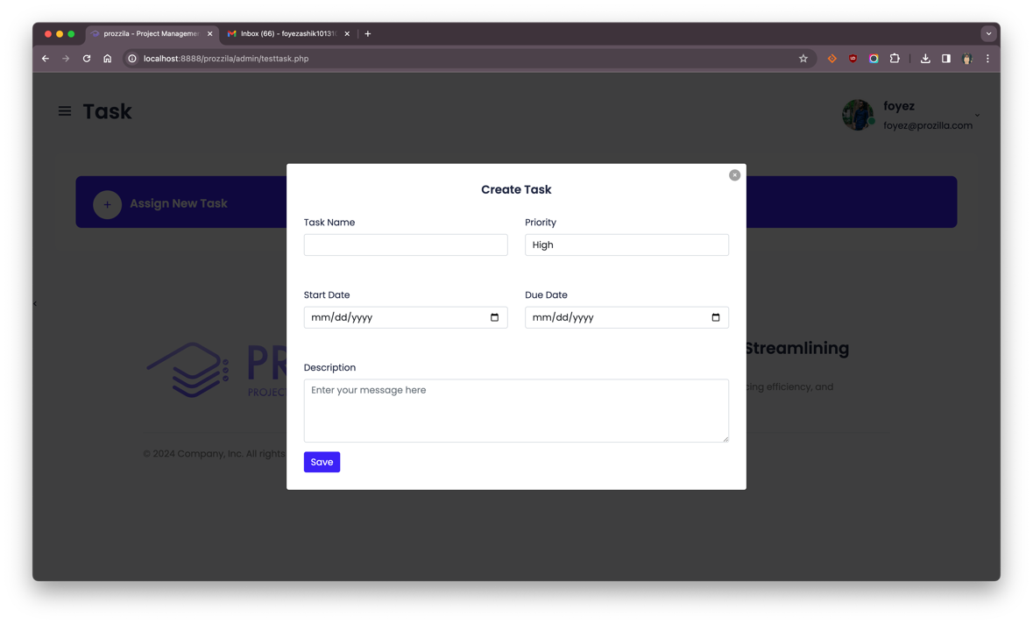This is a screenshot of project’s Create Task Page form. On this page, admin will add task name, priority, start date, due date and description.

## Fig 3.6.7 Create Task Page

## 3.6.8 Assign Task Page

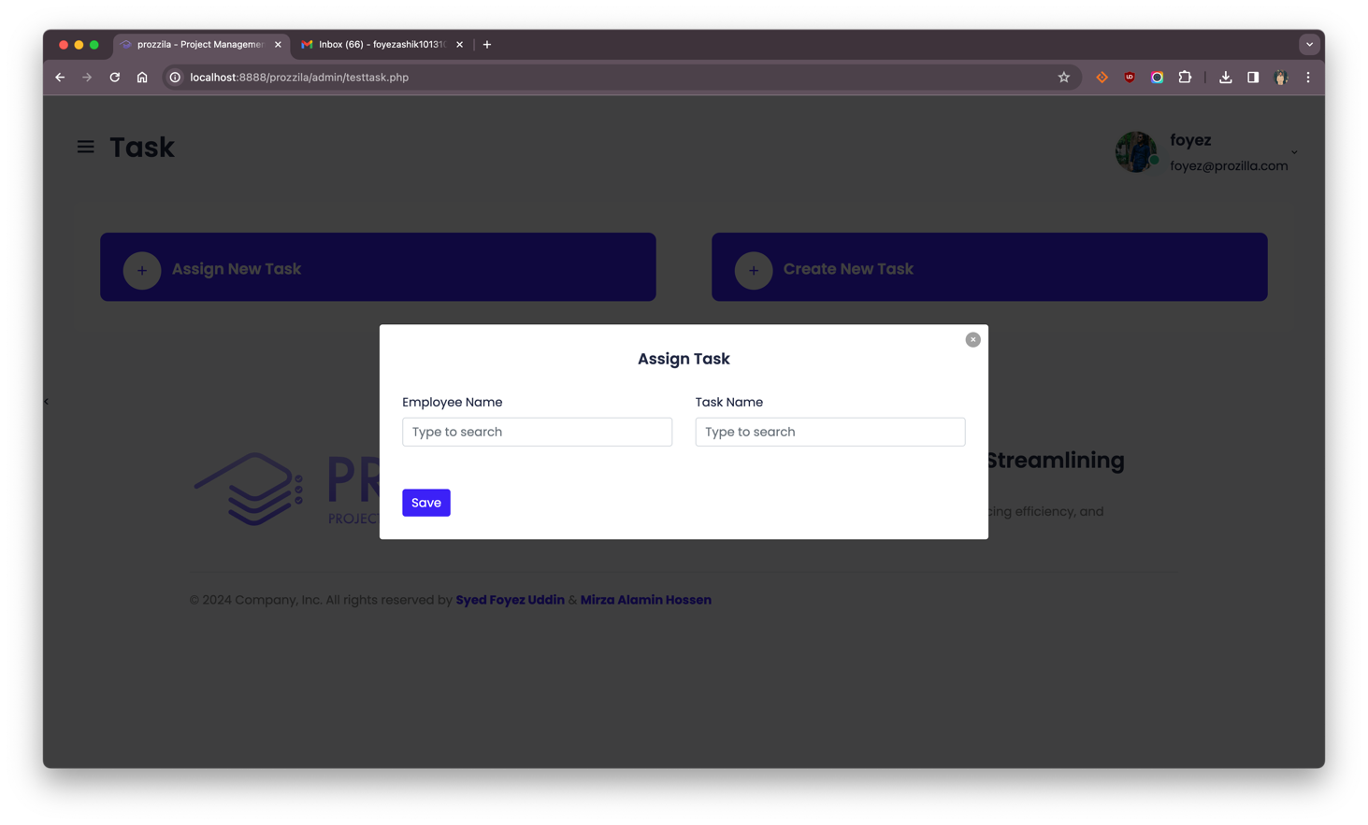This is the screenshot of project’s Assign Task page and on this page, admin will assign task to users.

## Fig 3.6.8 Assign Task Page

## 3.6.9 Kanban Board Page

The following is a screenshot of project’s Kanban Board and on this page, admin can add assign to task to card so that user can see their task on their Kanban Board.

## 

## Fig 3.6.9 Kanban Board Page

## 3.6.10 Assign to Card Page

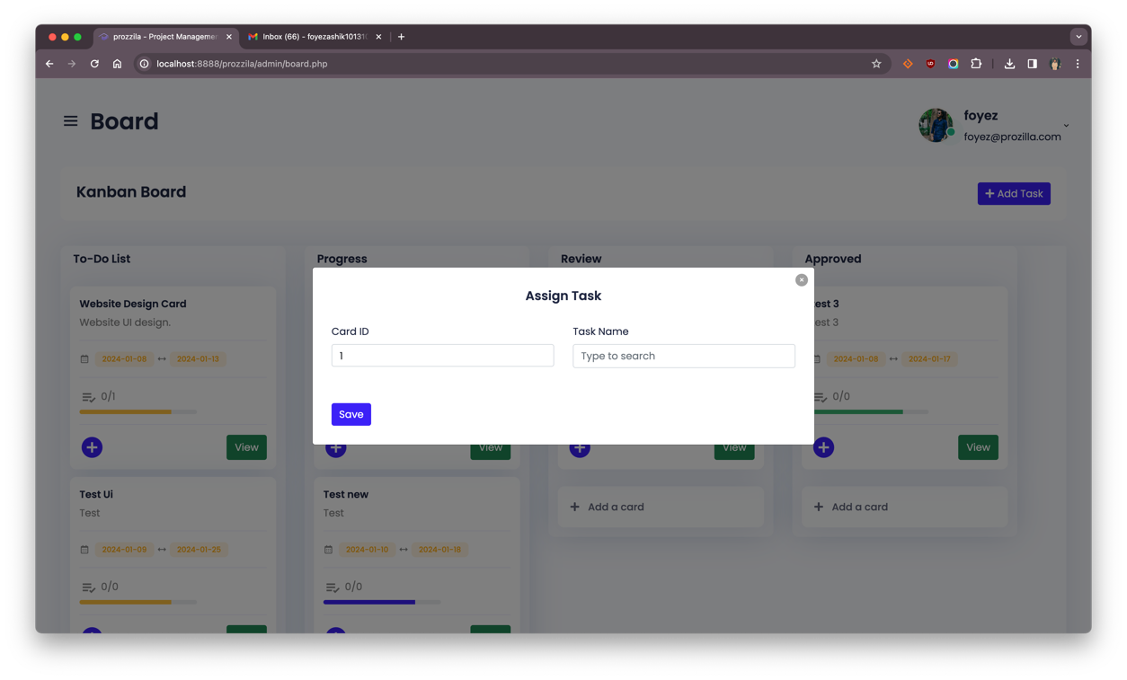The following is a screenshot of project’s Assign to Card Page and on this page, admin can search and add task name and add to card.

## Fig 3.6.10 Assign to Card Page

## 3.6.11 View Card Page

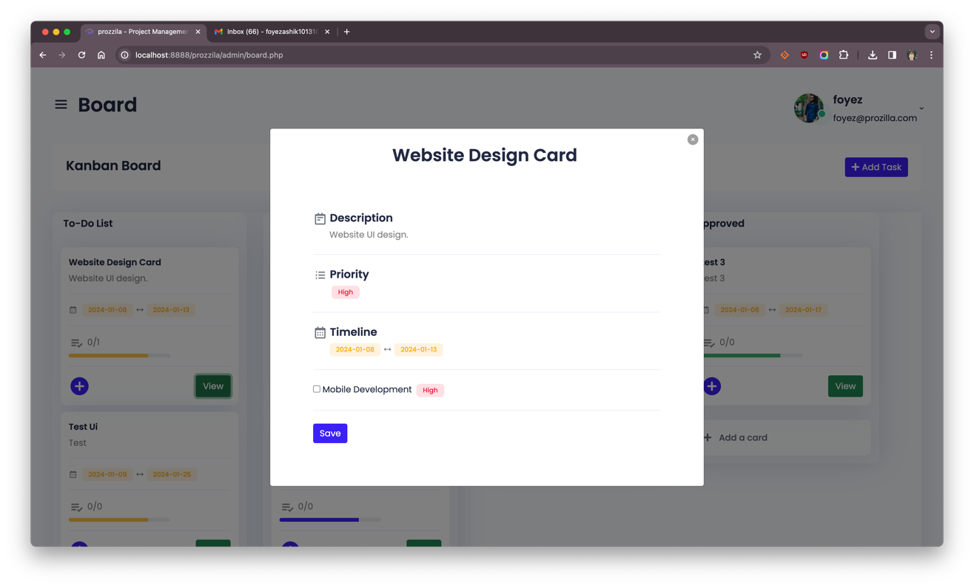This is a screenshot of project’s View Card Page and user can see task info here.

## Fig 3.6.11 View Card Page

## 3.6.12 New Project Page

This is a screenshot of project’s New Project Page where admin can add new project.

## 

## Fig 3.6.12 New Project Page

**CHAPTER 4**

**IMPLEMENTATION AND TESTING**

**4.1 Introduction**

In the implementation and testing phase of Prozzila, our primary focus is on delivering a robust project management solution. This section aims to provide a clear understanding of the project's goals and significance, highlighting our commitment to industry-standard practices and the strategic integration of advanced technologies. The subsequent discussion will delve into the systematic steps taken to ensure Prozzila's efficiency in meeting the evolving demands of project management.

**4.1.1 Requirement Collection and Analysis**

The success of the Prozzila is contingent upon a meticulous requirement collection and analysis process. It is imperative that the identified requirements are well-documented, actionable, measurable, testable, traceable, and directly related to the identified business needs or opportunities. This phase ensures that the system is defined to a level of detail sufficient for subsequent stages of system design and development. The collaborative effort of the project team, under the guidance of our esteemed project supervisor, was instrumental in analyzing and documenting the requirements effectively.

The key activities identified in the requirement analysis for Prozzila involve both Admin (Manager) and Users (Employees). The following activities have been identified:

1. **Admin and User Login:**
   1. **Description:** The system allows both Admin and Users to log into the system securely.
   2. **Objective:** Ensure secure and authenticated access for both Admin and Users.
2. **Admin System Management:**
   1. **Description:** The Admin is equipped with the ability to manage various aspects of the system.
   2. **Objective:** Empower the Admin with tools to oversee and administer the system efficiently.
3. **Task Management for Admin and Users:**
   1. **Description:** Admin can add tasks, assign tasks to users, manage project information, and access client details. Users, on the other hand, can view assigned tasks, update task status.
   2. **Objective:** Admin efficient task management by allowing Admin to oversee and assign tasks, and Users to view, update, and complete assigned tasks.
4. **Users Interaction with Kanban Board:**
   1. **Description:** Users can access a Kanban board to view tasks assigned to them. They have the capability to update task status and mark tasks as complete.
   2. **Objective:** Enhance user experience by providing a visual representation of tasks through a Kanban board, allowing Users to actively engage with their assigned tasks.
5. **Logout Functionality:**
   1. **Description:** Both Admin and Users can securely log out of the system.
   2. **Objective:** Ensure a secure and controlled logout process for all system users.

This comprehensive requirement analysis, including enhanced task management capabilities, lays the foundation for subsequent stages of system design and development. By addressing the specific needs of both Admin and Users, Prozzila aims to deliver a user-centric and functionally robust Project and Task Management System that aligns seamlessly with the dynamic demands of contemporary project management.

**4.1.2 Design Requirements:**

The design requirements for the Prozzila Project and Task Management System are structured to ensure an intuitive and user-friendly experience. The design process incorporates a use case diagram, use case description, E-R (Entity-Relationship) diagram, and a system flow-chart to provide a comprehensive understanding of the system's architecture. The design is intended to be easily interpretable, even for non-technical individuals, fostering accessibility and transparency. Any future modifications are accommodated, allowing for flexibility and scalability in the system's design.

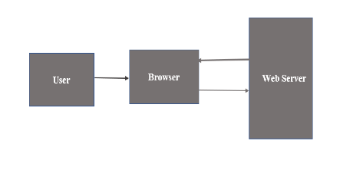

## Fig 4.1.2 Website Working Procedure

## 4.1.3 Completion

## The completion phase signifies the realization of the Prozzila Project and Task Management System, a dynamic platform meticulously designed to address the intricate challenges of project and task coordination. This system is dedicated to revolutionizing how projects are planned, executed, and monitored, fostering efficiency and collaboration.

## 4.1.4 Project Deliverables

## In the context of the Prozzila Project and Task Management System, project deliverables encompass a diverse array of tangible and intangible outcomes intended for delivery to end-users, stakeholders, and customers. The core software components, constituting the user interface, backend functionality, and database structure, serve as the foundational elements that enable seamless project and task management within the system.

## Furthermore, essential design artifacts such as use case diagrams, E-R diagrams, and system flow-charts provide valuable insights into the system architecture, enhancing transparency and aiding in future development or modifications. User training materials, comprising guides and tutorials, are crafted to support onboarding sessions, ensuring effective utilization of the Prozzila system. The system testing reports detail the comprehensive testing conducted, assuring the reliability, security, and performance of the system and providing a foundation for quality assurance.

## As part of ongoing development, the project delivers an update and enhancement roadmap, outlining planned updates, enhancements, and future features. This roadmap serves as a guide for future development efforts, demonstrating the commitment to continuous improvement and adaptability. It's crucial to differentiate project deliverables from milestones, as deliverables represent tangible results of the process, while milestones measure progress toward specific outputs. Additionally, within a contracted effort, specific deliverables may be explicitly outlined in contract documents, such as those listed in a Contract Data Requirements List or mentioned in the statement of work. These deliverables collectively ensure that the Prozzila Project and Task Management System meets the needs and expectations of its users and stakeholders, driving its success and effectiveness in contemporary project management.

**4.1.5 Resource Allocation**

## In the development of Prozzila, resource allocation was a meticulous process aimed at strategically managing a diverse array of assets to support the project's overarching goals. We sourced assets from reliable online platforms, encompassing tangible elements like hardware and software tools. However, the value of intangible resources, such as team unity, punctuality, and mutual trust, cannot be overstated. These qualities emerged as the essentials of our resource allocation strategy, playing a pivotal role in overcoming challenges and fostering an efficient working environment.

## Our allocation plan was intricately crafted to address the specific needs of each project phase. From initial development to testing and ongoing maintenance, the emphasis was on creating a cohesive and collaborative working atmosphere. The careful consideration of tangible and intangible assets ensured that Prozzila not only met functional requirements but also cultivated a positive team dynamic.

## Throughout this resource allocation journey, the intangible resources of team unity and trust proved to be the most precious. They not only contributed to the project's efficiency but also fostered effective communication and collective commitment. In the dynamic landscape of project management, our strategic allocation of resources, both tangible and intangible, has been fundamental to the successful progression of Prozzila.

**4.2 Pass/Fail Criteria**

## The establishment of clear pass/fail criteria is fundamental to evaluating the performance and reliability of the Prozzila Project and Task Management System. These criteria serve as benchmarks against which the system's functionality and behavior are assessed. The pass/fail criteria for this system are delineated as follows:

## Accurate Execution of One Criterion:

## Pass Criteria: The system must consistently and accurately execute at least one predefined criterion.

## Fail Criteria: Failure to accurately execute any predefined criterion will result in the system failing the evaluation.

## System Stability:

## Pass Criteria: The system must remain stable and operational under normal usage conditions.

## Fail Criteria: Any instance of system crashes or instability during operation will be considered a failure.

## Display of Expected Results:

## Pass Criteria: The system should consistently display expected results in response to user interactions and queries.

## Fail Criteria: Failure to display expected results, including errors or inaccuracies, will be deemed as a system failure.

## These pass/fail criteria are devised to ensure the reliability, accuracy, and stability of the Prozzila system. The system's ability to consistently meet the pass criteria and avoid the failure criteria is indicative of its successful implementation and performance. Rigorous testing and evaluation against these criteria will provide a robust measure of the system's effectiveness in meeting user requirements and expectations.

## 4.2.1 Testing Schedule

|  |  |
| --- | --- |
| **Test Phase** | **Time** |
| Testing plan creation | 1 week |
| Test specification | 1 week |
| Unit Testing | During development time |
| Validating use case | 2 weeks |
| User Interface Test | 1 week |
| Load Test | 1 week |
| Release to production | 1 week |

## Table 4.2.1 Testing Schedule

## 4.3 Testing Environment

## The testing environment for the Prozzila Project and Task Management System is a crucial component in ensuring the comprehensive and accurate evaluation of the system's functionalities. The testing environment encompasses a range of hardware and software components to facilitate the execution of test cases and assess the system's performance under varying conditions. Key elements of the testing environment for Prozzila include:

## Test Data

## Operating System

## Browser

## Hardware with Server Operating System

## This diverse and inclusive testing environment is designed to provide a thorough assessment of the Prozzila Project and Task Management System across different scenarios. By encompassing various hardware and software configurations, the testing environment ensures the reliability, compatibility, and effectiveness of the system in meeting the dynamic needs of its users.

## 4.4 Testing Implementation

## Testing implementation is a critical phase in the development of the Prozzila Project and Task Management System to ensure a robust and error-free user experience. The significance of testing lies in identifying and addressing potential errors or unexpected behaviors that could arise during real-world usage. Authentication serves as a key aspect of our testing strategy, ensuring secure access to the system. The testing implementation for Prozzila is outlined as follows:

## Authentication Testing:

## Description: Authentication is a crucial component of system security. Various inputs for login credentials have been systematically tested to validate the project’s authentication process.

## Result: The system demonstrates the expected behavior, allowing access only upon successful authentication.

## Main Screen Navigation:

## Description: After successful authentication, users enter the main screen of the software. Testing involves navigating to different sections from the main screen.

## Result: Navigation is successfully executed without errors, ensuring a seamless transition between different screens.

## Task Management Operations:

## Description: Testing includes adding and updating tasks within the system. Different scenarios are considered to assess the reliability of task management functionalities.

## Result: Tasks can be added and updated without encountering any issues, ensuring the smooth operation of task management features.

## The comprehensive testing implementation outlined above underscores our commitment to delivering a Prozzila system that is not only secure but also functions seamlessly across various modules. Rigorous testing of authentication, navigation, and task management ensures that the system meets the highest standards of reliability and performance. This approach mitigates potential risks and contributes to the development of a robust and user-friendly Project and Task Management System.

## 4.5 Test Results and Reports

## The Prozzila Project and Task Management System underwent meticulous testing, yielding positive results across various modules. The system's versatility was evident in addressing diverse project management challenges, empowering efficient control over tasks, timelines, and team collaboration. User authentication processes were successfully implemented, ensuring secure access for all users based on their respective credentials. The project manager seamlessly interconnected tasks to users through the system, and user accessibility features aligned with specified projects, establishing a secure and controlled environment. Task management functionalities, including creation, assignment, and tracking, operated smoothly, facilitating effective project task allocation. Collaboration features within Prozzila enhanced coordination, contributing to a user-friendly, secure, and efficient platform for project and task management. The positive test results underscore the system's commitment to delivering high-quality and reliable project management solutions.

**CHAPTER 5**

**CONCLUSION AND FUTURE WORKS**

**5.1 Conclusion**

## In the development process, we have embraced a prototyping model, anticipating the identification of errors and challenges during the prototype phase. User feedback holds a pivotal role in refining the Web Application for subsequent versions, fostering continuous improvement.

## Our approach, drawing parallels with a business plan's conclusion, encapsulates essential points and highlights the strengths of the system. The commitment to a user-centric model and the integration of industry best practices positions the project to be a successful solution, meeting the diverse needs of project management. The iterative nature of development, coupled with user engagement and adherence to evolving standards, propels the system toward its goal of providing a reliable and efficient project and task management platform.

## In summary, the development of our Project and Task Management System signifies a commitment to streamlining project processes and enhancing efficiency. By incorporating user-friendly interfaces, advanced features, and adherence to industry best practices, the system aims to revolutionize project management. The iterative development process, coupled with user engagement and feedback, ensures continuous improvement and adaptability to evolving needs.

## Much like successful project management itself, our system's strength lies in its ability to evolve, respond to user requirements, and provide a reliable platform for effective project and task management. As we conclude this phase, we anticipate the system's positive impact on project outcomes, user satisfaction, and the overall landscape of project management practices.

* 1. **Future Work**

The development of 'Prozzila: A Project and Task Management System' lays the groundwork for ongoing enhancements and advancements. Envisaging the evolution of the system, potential areas for future work and development include:

* **Mobile Application Integration:** Explore the development of a mobile application for 'Prozzila,' enabling users to access and manage projects on the go. This feature would enhance convenience and flexibility, aligning with the dynamic nature of modern work environments.
* **Integration with External Services:** Consider further integration with external services, such as collaborative platforms, communication tools, and cloud services, to expand the system's capabilities. This integration aims to provide users with a comprehensive and seamless project management experience.
* **Advanced Analytics and Reporting:** Develop advanced analytics and reporting functionalities to empower project managers and administrators with deeper insights. This would facilitate data-driven decision-making, offering valuable metrics on project performance, team efficiency, and resource allocation.
* **AI and Machine Learning Integration:** Explore the integration of artificial intelligence (AI) and machine learning (ML) algorithms to enhance personalized recommendations, automate routine tasks, and optimize project workflows. This addition aims to improve efficiency and provide intelligent insights.
* **International Collaboration and Compatibility:** Expand the system's capabilities to support international collaboration by incorporating features such as multi-language support, time zone adjustments, and compatibility with international project management standards. This would cater to the diverse needs of global project users.

These envisioned enhancements are geared towards further elevating the functionality, efficiency, and user experience of 'Prozzila: A Project and Task Management System.' The goal is to keep the system at the forefront of project management technology, meeting the evolving demands of project users and contributing to the advancement of the field.

**References**

[1] Kerzner, H. Project Management: “A Systems Approach to Planning, Scheduling, and Controlling”, John Wiley & Sons. 2017.

[2] Ralph Moseley, M. T. Savaliya, “Developing Web Applications”, Wiley India Pv. Ltd., 2011.

[3] <https://ieeexplore.ieee.org/document/4839866>

[4] <https://ieeexplore.ieee.org/document/5718942>

[5] <https://ieeexplore.ieee.org/document/7380291>

[6] <https://ieeexplore.ieee.org/document/7764421>

[7] <https://ieeexplore.ieee.org/document/8862073>